Learning Activity Types (LAT) Lesson Planning Guide

Use this guide with the process described in the LAT Short Course and the article Grounded Tech Integration in planning one technology-integrated lesson in your preferred grade level and subject area.

- Instructional Context
Grade Level: | Content Area:
1a. Texas Essential Knowledge and Skills (TEKS) (copy and paste 1-3 standards):

1b. Specific learning goals/objectives for the students, using specific verbs that identify what the students will know or be able to do as a result of the lesson:

For step 2, follow the Elementary or Secondary LAT short course module 6, found under more…)

- Pedagogical Continua
Move the red dots to the place on each line that indicates the anticipated contextual conditions of your lesson.  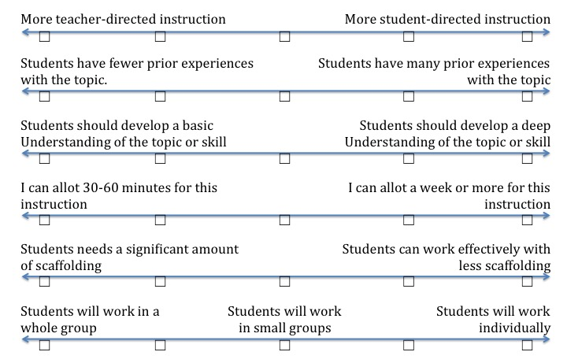 | Notes:

For steps 3a, 3b, and 3c, follow the Elementary or Secondary LAT short course modules 7 and 8, found under more…)

3a. Learning Goal Classification and Taxonomy Exploration
Learning Goal (from step 1b) | Content or Process Focus? | Relevant Taxonomy Sub-Heading(s)

3b. LAT and Technology Selections
Learning Goal (from step 1b) | Possible LATs | Selected LATs | Possible Technologies | Selected Technologies

3c. Final Sequence of LATs and Technologies
LATs (List the selected LATs in logical order) | Materials (List digital technologies and non-digital items needed)

3d. Relative Advantage
Describe the relative advantage of using technology in the lesson (i.e., how the technology selected would help students better meet both the TEKS and the ISTE standards).

4. Procedure
From the LATs listed in step 3c, describe in your own words the steps that the teacher and students would follow when engaging in the activities. Try to include options that provide multiple means of representation, expression, and engagement.

5. Assessment
Identify one or more assessment strategies (e.g., rubric, checklist, quiz, test, etc.) that could be used to evaluate whether the students have met the lesson objectives. Be sure that the assessment method is consistent with the objectives and procedures.

- Before turning in this draft of your lesson plan, use the checklist below to self-assess your work. By doing so, you can avoid having to redo your work later!

___ Objectives are aligned with the Texas Essential Knowledge and Skills (TEKS), providing clear statements of observable student behaviors that demonstrate learning. (Step 1)

___ Pedagogical decisions are appropriate and are reflected in activities and materials selected. (Steps 2-5)

___ Multiple potential activity types, technologies, and other non-digital materials are listed. (Step 3)

___ The technology and other materials selected are appropriate and offer clear relative advantage over options. (Step 3)

___ The activities and technologies selected are essential to helping students accomplish the lesson objectives and the standards with which they are aligned. (Step 1 and 3)

___ Procedures provide options for multiple means of representation, expression, and engagement, when possible. (Step 4)

___ Procedures are described in sufficient detail and in your own words. (Step 4)

___There is a good match between objectives and assessments. (Steps 1 & 5)

